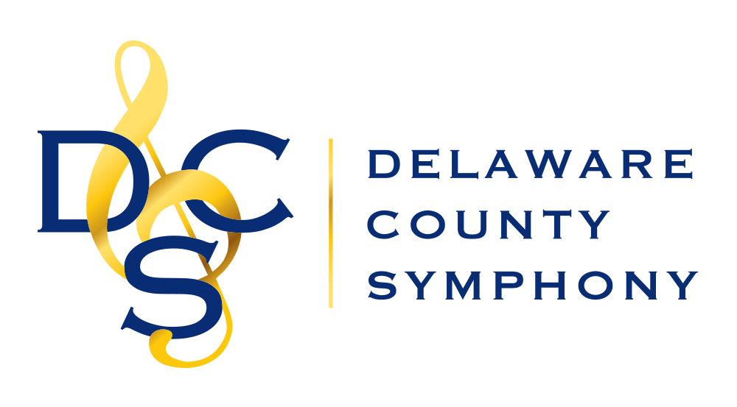

40th ANNUAL YOUTH CONCERTO COMPETITION
Application Form

Eligibility: Students in 9th through 12th grade living or studying in the tri-state area
Date: Saturday, January 22nd, 2022
Place: Darlington Arts Center, 977 Shavertown Rd Garnet Valley, PA 19060

Application Deadline: December 22, 2021

AUDITION PROCEDURES
➢ Contestants must furnish their own accompanists.
➢ One copy of the music with accompaniment must be provided for the judges.
➢ It is expected that contestants will prepare the entire work to be performed. The judges will select portions of the work to be played during the 15-minute audition.
➢ Each contestant will receive a certificate of participation by e-mail after the audition.
➢ One winner will be named and will receive a $300 cash prize in addition to a performance with the symphony on May 1, 2022. If no contestant is considered qualified by the judges, no winner will be named.

Contestant audition times will be e-mailed January 5, 2022. All auditions will take place between the hours of 10:30am and 4pm on the day of the audition. Feel free to contact Competition Chair, Rebecca King, with any questions at rking77@gmail.com or 610-761-8970.

CUT HERE

DELAWARE COUNTY SYMPHONY 40th ANNUAL YOUTH CONCERTO COMPETITION
Application Form
Email to rking77@gmail.com or Mail to: Rebecca King, 114 Juniper Court, Glen Mills, PA 19342

Student Name Phone E-Mail
Parent Name_______________________Phone___________________E-Mail___________________
Teacher Name______________________Phone__________________ E-Mail____________________
Student’s Mailing Address

Instrument Grade Age School
Title Composer
Approx. Duration Accompanist name and phone

