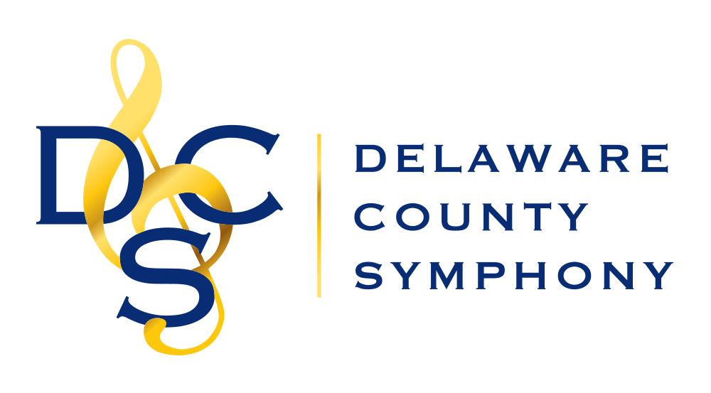

39th ANNUAL YOUNG ARTISTS COMPETITION
Application Form

Eligibility: Students in 9th through 12th grade, living or studying in the tri-state area

Application Deadline: December 15, 2020
Submission Date: January 15, 2021

AUDITION PROCEDURES
➢ Contestants must furnish their own accompanists.
➢ The piece must be a solo work, with or without accompaniment or piano reduction and last 7-15 minutes. The recording may be stopped between movements, but no performance shall be edited for any reason.
➢ It is expected that contestants will prepare the entire work to be performed.
➢ More information will be given regarding the recording process and submission after the application has been submitted.
➢ Each contestant will receive a certificate of participation by mail after the audition.
➢ One winner will be named and will receive a $300 cash prize in addition to a performance with members of the Delaware County Symphony in April 2021 (recording date to be announced). If no contestant is considered qualified by the judges, no winner will be named.

Feel free to contact the Competition Chair, Rebecca King, with any questions at rking77@gmail.com or leave a message at 610-761-8970.

DELAWARE COUNTY SYMPHONY 39th ANNUAL YOUNG ARTISTS COMPETITION
Application Form
Email to rking77@gmail.com or Mail to Rebecca King, 114 Juniper Court, Glen Mills, PA 19342

Student Name Phone E-Mail

Parent Name______________________Phone___________________E-Mail_____________________
Mailing Address

Instrument Grade Age School

Title Composer

Approx. Duration Accompanist name and Phone #

Teacher’s Name Phone

Teacher’s Address

